

VAWG Service Co-ordinator

Job Description

Job Title: VAWG Service Co-ordinator

Location: Bede offices, Southwark SE16, with travel to other locations across Southwark.

Hours: FTE 35 hours/week (excluding lunch break). Schedule may vary according to the organisation’s needs. Jobholders work with colleagues to cover core service hours of 8:00 am to 6:00pm, Monday to Friday. TOIL may be granted for extra hours worked, in advance and by agreement with the service manager.

Pay grade: £30,248.40 pa FTE (£16.62/hr), rising with experience.

Reporting Structure

Reporting to: Starfish Deputy Service Manager

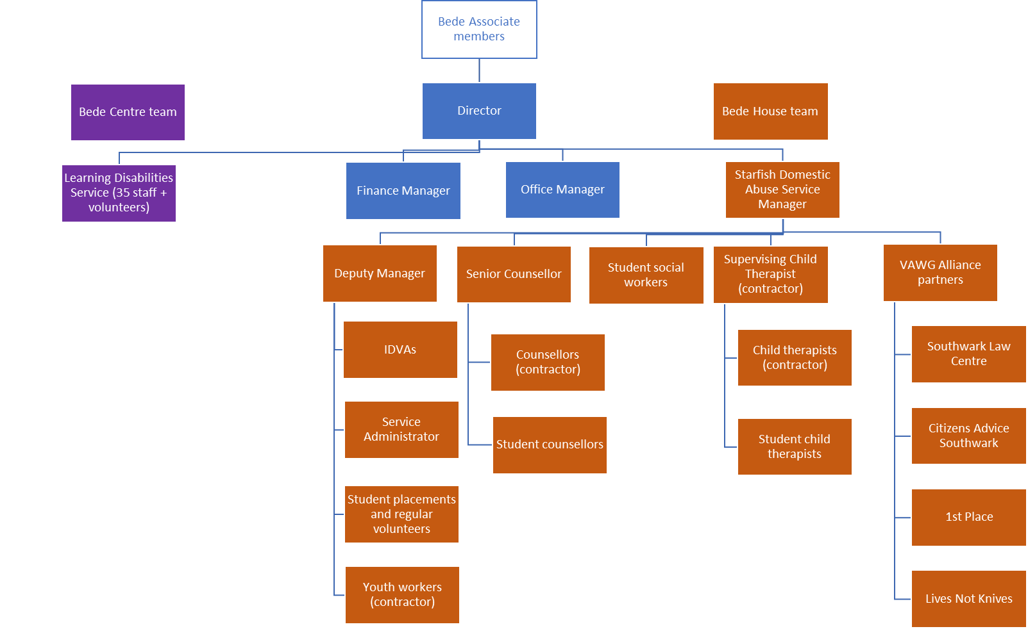
The VAWG Service Co-ordinator will provide high-quality administrative and coordination support to the Starfish service, ensuring the smooth day-to-day operation of a busy and fast-paced commissioned service supporting women, children, families, and male victims affected by domestic abuse, sexual violence, and other forms of violence against women and girls (VAWG).

The postholder will play a key role in ensuring that all individuals accessing the service, including women, children, young people, men, and boys, receive a responsive, professional, and trauma-informed service, supporting timely access to appropriate interventions and specialist support.

The postholder will act as the first point of contact for referrals, enquiries, and visitors, undertaking initial referral triage, maintaining service inboxes, coordinating appointments, supporting waiting list management, and ensuring accurate records are maintained across organisational systems.

Working closely with managers and practitioners, the postholder will help ensure referrals are processed efficiently, risks are identified and escalated appropriately, and clients receive a professional, responsive, and trauma-informed service. The role will also provide essential office coordination and administrative support to enable the wider team to deliver high-quality services.

Main responsibilities

The Bede VAWG Service Co-ordinator will:

- Provide duty cover and first point of contact for referrals from current and potential clients, drop-in visitors, professionals, and general callers to the Starfish service. Maintain oversight of general referral inboxes.
- Collect referral information and liaise with managers to ensure that the referral is suitable for the service, ensure any immediate risks are identified and addressed, and book clients for risk assessment meeting. Where not suitable, identify other suitable services and refer.
- Maintaining counselling and therapy waitlists; calling clients to check availability and suitability.
- Provide accurate and clear case notes on Bede systems.
- Support managers in collating data for accurate, timely and effective outcomes reporting.
- Liaise with team members to ensure information is conveyed accurately and escalated appropriately.
- Call clients to arrange availability and enter details into CRM and office systems.
- Liaise with counsellors with regard to appointments and cancellations
- Provide all-round admin support for the Starfish team, ensuring the office and systems are kept clean and tidy.
- Enter and maintaining information on Bede’s CRM and office-based systems.
- Manage appointment reminders for clients to ensure attendance and follow up any no-shows.
- Manage the service in-house calendar and ensure team members’ time is used efficiently and accurately
- Work with other professionals, participating in meetings as required.
- Follow service protocols with regard to client engagement
- Communicate effectively and according to the needs of each individual.
- Observe confidentiality of information regarding people using our services.
- Ensure equipment is used safely and properly and stored properly after use.
- At all times work in a safe manner, with due regard for the Health and Safety needs of individual clients and according to Bede’s policies or the prevailing policies at any off-site venue.
- Adhere to safeguarding legislation, SafeLives quality standards and Bede’s combined safeguarding policy and procedures and escalate any concerns promptly to a manager.
- Play a full role in ensuring effective communication across the service, using systems, reporting forms and individual’s files where appropriate.
- Write reports and record information as necessary, in appropriate formats if required.
- Use Bede administrative procedures such as timesheets and petty cash claims.
- Attend team meetings, supervision and appraisal sessions and undergo training according to identified needs.
- Contribute to the overall effectiveness and development of the Bede Starfish Service and Bede House Association, making best use of space and resources.
- Undertake any other duties reasonably requested from time to time.

Person Specification

Please email completed applications to admin@bedehouse.org.

Essential requirements:
- Excellent analytical skills to absorb, prioritise, summarise and pass on key information gathered from a wide variety of sources
- Ability to communicate, both in person and in writing, to quickly establish excellent working relationships with a wide range of individuals, including clients, representatives of programme funders and partners, local authority and health agencies
- Highly-developed IT literacy suited to a paperless office running Microsoft 365 and a range of CRM systems.
- Highly organised and able to manage competing priorities in a fast-paced setting.

Desirable

Desirable requirements:
- Good understanding of VAWG issues and effects of trauma
- Good understanding of VAWG services and multi-agency partnership structures
- Training, qualifications or demonstrable equivalent experience relevant to domestic abuse
- Relevant administration, business support, or customer service qualification.

An Enhanced Disclosure and Barring Service check will be undertaken.

Last reviewed July 2026

