

Bede IDVA

Job Description

Job Title: IDVA

Location: Bede offices, Southwark SE16, with travel to other locations across Southwark.

Hours: FTE 35 hours/week (excluding lunch break). Schedule may vary according to the organisation’s needs. Jobholders work with colleagues to cover core service hours of 8:00 am to 6:00pm, Monday to Friday. TOIL may be granted for extra hours worked, in advance and by agreement with the service manager.

Pay grade: £28,860 pa FTE (£15.86/hr) with review pending, rising with experience.

Reporting Structure

Reporting to: Starfish Deputy Service Manager

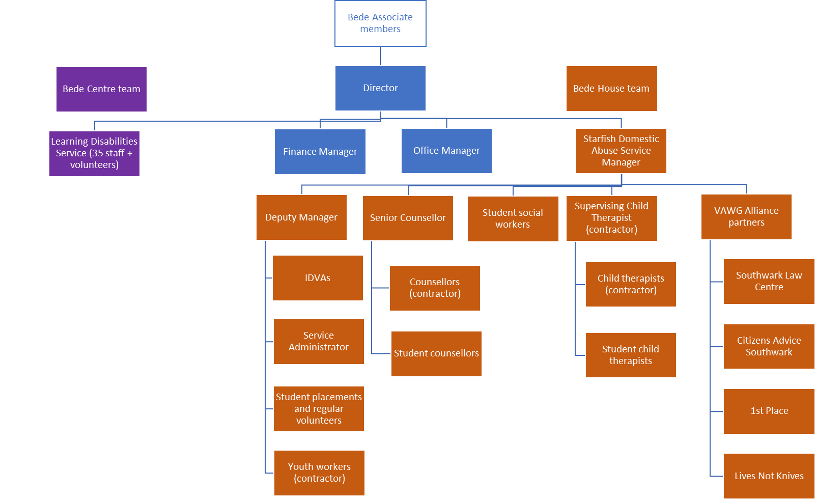
Established for over 20 years, Bede Starfish offers a service underpinned by a client-centred, holistic approach, acknowledging every client’s individuality and ensuring services are completely tailored to their needs. The team provides a mix of advocacy, specialist counselling and art therapy to both adults and children who have experienced domestic and gender-based abuse.

Main responsibilities

Bede IDVAs will:

- Identify and assess the risks and needs of individuals making initial contact about experiences of gender-based abuse.
- Participate in the duty rota answering incoming referrals by phone, email, text or in person.
- Work with the Bede Deputy Service Manager and other colleagues to appropriately triage incoming referrals.
- Conduct risk assessments with clients using DASH RIC and other appropriate resources and expertise.
- Provide proactive, risk-based safety planning and advice with clients experiencing gender-based abuse, tailoring the approach to each individual’s background, circumstances and needs.
- Work with clients to develop a individually-tailored support plan to fully meet their needs and support their empowerment and healing.
- Support clients to safely recognising the features and dynamics of abuse present in their situation, with a trauma-informed, healing-focused approach.
- Consistently check in with clients and revisit progress with them, addressing emerging issues and needs within an agreed framework.
- Creatively re-engage clients who disengage, using strengths-based approaches
- Providing advocacy, and information to victims including exploration of legal and civil options, housing, health and finance and support clients through the criminal justice system. Support clients through the CJS system, explaining the procedures and their role and rights within that system and attend hearings at court and meetings with them as necessary.
- Participate fully in the Multi-Agency Risk Assessment Conference (MARAC) framework: refer clients, attend and participate in meetings by being the voice of the client and follow up actions agreed in the MARAC keeping the client’s safety at the forefront of proceedings.
- Liaise with partner organisations to facilitate seamless support for clients. Advocate at and facilitate meetings with other agencies/services as necessary, for instance, solicitors, benefit agency, housing, etc.
- Develop and maintain good and effective relationships with key partner organisations across Southwark, to support a multi-agency approach to support.
- Ensure partner agency staff are suitably trained, aware and competent in recognising and referring VAWG issues.
- Provide constructive support and challenge to professional decision-making processes, to maintain consistently high quality standards and ensure the client’s voice is influential.
- Conduct outreach and intervention work at multiple co-locations across Southwark, such as GP surgeries, Police CSU and Family Hubs.
- Facilitate training and small groups, both of clients and other professionals
- Advocate for clients at Social Services meetings
- Understand and advocate for clients within the legal framework relating to the protection of children and adults at risk, including the policy and procedures of the Local Safeguarding Children’s Board and Safeguarding Adults.
- Work alongside a team of staff to reflect the diverse community and the needs of all people experiencing gender-based abuse in Southwark, including those with particular vulnerabilities. Draw on national and local expertise and knowledge to deliver individual, bespoke services with respect, dignity and sensitivity.
- Maintain timely, accurate and confidential case management records and contribute to monitoring information for the service as directed by the Service Manager.
- Produce high-quality written professional reports, safety plans, risk assessments and multi-agency correspondence.
- Contribute to a team culture that supports and motivates colleagues.
- Attend internal and external meetings as directed and participate in regular supervision and appraisal meetings with the Manager.
- Comply with Bede House Association’s policies and procedures.
- Keep up-to-date with developments in legislation and practice and regularly review in supervision on performance in this area.
- At all times work in a safe manner, with due regard for the Health and Safety needs of individual service users and according to Bede’s policies or the prevailing policies at an off-site venue.
- Be aware of and adhere to relevant safeguarding policies and procedures and report any concerns promptly
- Ensure effective communication of necessary information
- Comply with Bede’s policies and procedures on data protection legislation, confidentiality and information sharing
- Comply with Bede’s administrative procedures such as timesheets and petty cash claims
- Attend supervision and appraisal sessions and undergo training according to identified needs
- Contribute to the overall effectiveness and development of the service and Bede House Association
- Remain up-to-date and comply with organisational procedures, policies and professional codes of conduct to uphold standards of best practice
- Undertake any other duties reasonably requested from time to time

Person Specification

Essential requirements:
- At least 1 years’ experience (full time equivalent) of working with high-risk clients experiencing domestic abuse or similar crises.
- At least 1 years’ experience (full time equivalent) managing and reviewing own caseload
- A relationship-building, coaching mindset with the ability to respond empathetically, guide, motivate and empower clients toward safety, stability and long-term change.
- An ability to build trust and engagement with a diverse client group, including with clients who are in crisis, ambivalent, fearful or reluctant to engage.
- A confident communicator who can represent the service and build relationships with statutory partners, other community organisations and activists.
- Willingness to think innovatively and use creative problem-solving approaches to engage clients facing complex challenges or multiple disadvantages
- Ability to maintain professional boundaries and adhere to Bede’s code of conduct
- Confidence, emotional resilience and professional curiosity when navigating challenging situations or multi-agency disagreements
- Willingness to engage and share in ongoing continuing professional development to grow specialist VAWG expertise
- Excellent understanding and ability to identify domestic abuse and VAWG risks, coercive control and the impact of trauma on people and families experiencing abuse.
- Ability to use motivational interview techniques and understand the impact of the stages of change
- Proficiency in written and spoken English, to a standard required to read, write and understand professional reports, letters and case notes
- Proficiency in Microsoft 365 tools, ability to use digital case management systems and to adhere to shared information management and filing systems.
- Excellent practical understanding of the civil and criminal justice remedies available to people affected by domestic abuse and VAWG
- Working, up-to-date knowledge of relevant support services available to support clients in Southwark.
- Working understanding of relevant legislation as it applies to day-to-day casework to support people experiencing domestic and gender-based abuse
- Practical grasp of the day-to-day application of equality legislation, principles and practice in the VAWG sector
- Excellent understanding of Child Protection and Vulnerable Adult practices and procedures
- Ability to work as part of a small team
- Ability to work effectively from different locations, including working remotely from home as required
- Ability to plan and prioritise own workload and work effectively to deadlines
- Ability to positively influence others in the team to plan and achieve agreed goals
- Willingness to enhance the reach and reputation of the charity as a best practice provider

Desirable requirements:
- Good standard of tertiary level education or equivalent knowledge
- Formal qualification in domestic or sexual abuse support (full training will be provided as part of the role)
- Experience in facilitating domestic abuse support groups or in similar environments
- Experience in organising and presenting training programmes
- Prior experience as a police IDVA

An Enhanced Disclosure and Barring Service check will be undertaken.

This post is open to women only as this is considered to be a Genuine Occupational Requirement under Schedule 9, Part 1, of the Equality Act (2010).

Last reviewed December 2025

