

Bede ISVA

Job Description

Job Title: ISVA

Location: Bede offices, Southwark SE16, with travel to other locations across Southwark.

Hours: FTE 35 hours/week (excluding lunch break). Schedule may vary according to the organisation’s needs. Jobholders work with colleagues to cover core service hours of 8:00 am to 6:00pm, Monday to Friday. TOIL may be granted for extra hours worked, in advance and by agreement with the service manager.

Pay grade: £30,248.40 pa FTE (£16.62/hr) rising with experience.

Reporting Structure

Reporting to: Starfish Deputy Service Manager

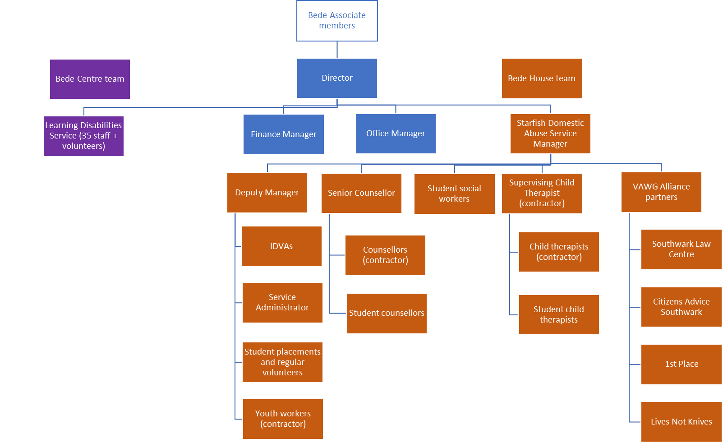
Established for over 20 years, Bede Starfish offers a service underpinned by a client-centred, holistic approach, acknowledging every client’s individuality and ensuring services are completely tailored to their needs. The team provides a mix of advocacy, specialist counselling and art therapy to both adults and children who have experienced domestic and gender-based abuse.
Main Responsibilities
Bede ISVAs will:

- Identify and assess the risks and needs of individuals accessing the service following experiences of sexual violence and wider VAWG issues.
- Participate in the duty rota, responding to referrals via phone, email, text and face-to-face contact.
- Carry out risk and needs assessments using DASH RIC and professional judgement.
- Develop tailored safety and support plans that respond to individual risks and circumstances.
- Provide trauma-informed, person-centred support and advocacy to survivors of sexual violence and wider gender-based abuse.
- Support clients to understand their rights and options, including criminal and civil justice pathways, and support them through police processes and court attendance where required.
- Provide advocacy around housing, health, welfare benefits, safeguarding and access to specialist services.
- Support and advocate for clients throughout the criminal justice process, including liaison with Police, SARCs, hospitals, forensic services, legal professionals and court services.
- Develop and maintain effective relationships with key partner agencies (including Police, SARCs, health services, safeguarding teams, housing, social care, mental health services, legal services and community organisations) to ensure coordinated support.
- Make appropriate referrals and liaise with partner agencies, including counselling, sexual health, housing, welfare, substance misuse and specialist VAWG services.
- Work alongside a team of staff to reflect the diverse community and the needs of all people experiencing gender-based abuse in Southwark, including those with particular vulnerabilities. Draw on national and local expertise and knowledge to deliver individual, bespoke services with respect, dignity and sensitivity.
- Maintain timely, accurate and confidential case management records and contribute to monitoring information for the service as directed by the Service Manager.
- Produce high-quality written professional reports, safety plans, risk assessments and multi-agency correspondence.
- Contribute to a team culture that supports and motivates colleagues.
- Attend internal and external meetings as directed and participate in regular supervision and appraisal meetings with the Manager.
- Comply with Bede House Association’s policies and procedures.
- Keep up-to-date with developments in legislation and practice and regularly review in supervision on performance in this area.
- At all times work in a safe manner, with due regard for the Health and Safety needs of individual service users and according to Bede’s policies or the prevailing policies at an off-site venue.
- Be aware of and adhere to relevant safeguarding policies and procedures and report any concerns promptly
- Ensure effective communication of necessary information
- Comply with Bede’s policies and procedures on data protection legislation, confidentiality and information sharing
- Comply with Bede’s administrative procedures such as timesheets and petty cash claims
- Attend supervision and appraisal sessions and undergo training according to identified needs
- Contribute to the overall effectiveness and development of the service and Bede House Association
- Remain up-to-date and comply with organisational procedures, policies and professional codes of conduct to uphold standards of best practice
- Undertake any other duties reasonably requested from time to time
Person Specification
Essential requirements:
- At least one year's experience (or equivalent) working with individuals affected by sexual violence, domestic abuse, VAWG or similar crisis situations.
- Experience managing and prioritising a caseload effectively.
- Strong communication and relationship-building skills with the ability to engage individuals from diverse backgrounds.
- Ability to build trust and support individuals experiencing crisis, trauma or complex needs.
- Knowledge of the impact of sexual violence, trauma and coercive or controlling behaviours.
- Emotional resilience, sound judgement and the ability to work effectively in challenging situations.
- Ability to maintain professional boundaries and work within safeguarding procedures.
- Excellent written and verbal communication skills, including report writing and case recording.
- Competent use of Microsoft Office (Word, Outlook, Excel, PowerPoint) and digital case management systems.
- Knowledge of criminal justice, safeguarding and relevant support pathways.
- Ability to work independently and as part of a small team.
- Commitment to equality, diversity and inclusive practice.
- Willingness to undertake training and develop specialist knowledge and skills.
- Excellent understanding of Child Protection and Vulnerable Adult practices and procedures
- Ability to work effectively from different locations, including working remotely from home as required
- Ability to plan and prioritise own workload and work effectively to deadlines
- Ability to positively influence others in the team to plan and achieve agreed goals
- Willingness to enhance the reach and reputation of the charity as a best practice provide

Desirable requirements:
- Good standard of tertiary education or equivalent knowledge and experience
- Formal qualification in domestic abuse or sexual violence support (full training will be provided)
- Experience facilitating support groups or delivering training
- Previous experience within an ISVA, IGVA, IDVA or related advocacy role

An Enhanced Disclosure and Barring Service check will be undertaken.

This post is open to women only as this is considered to be a Genuine Occupational Requirement under Schedule 9, Part 1, of the Equality Act (2010).

Last reviewed May 2026

