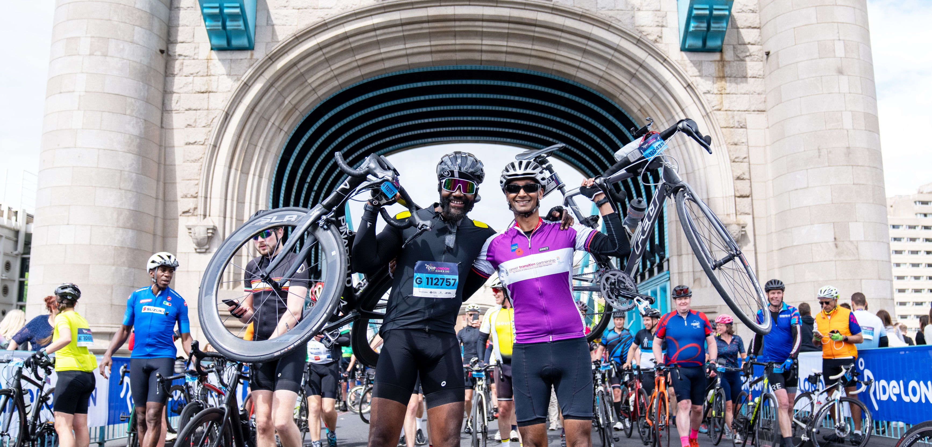  bede invites you to cycle the FORD RIDElondon-ESSEX 100 to hELP build stronger, happier communities in southwark!  SUNDAY 26 may 2024  Bede helps some of the most vulnerable people in our community overcome challenges and grow their potential. You can support us by cycling the Ford RideLondon-Essex 100 and raising money to support Bede’s work in one of its charity places.  Ford RideLondon-Essex 100 takes place on Sunday 26th May 2024, taking in some of the counties’ most iconic landmarks and impressive sceneries!  To find out more about this world class event, please visit  Ford RideLondon.co.uk  If you cycle for Bede, we will give you a goody bag alongside the finishers’ medal and souvenir T-shirt given at the event for participating. Ford RideLondon-Essex 100 will also provide you with an app where you can record your stats, track other runners and listen to inspiring music!  So…want to cycle for Bede?  To secure your place in the 2024 Ford RideLondon-Essex 100, please read and complete this form returning it to Gwen Green, T: 0207 237 388, before Monday 15th April 2024. Thank you.  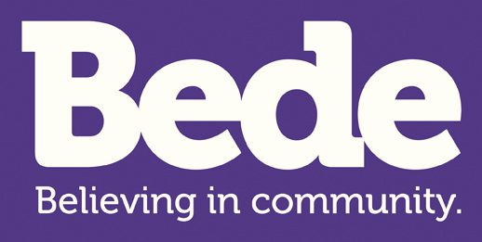 |  | FORD RIDELONDON-ESSEX 100 PLEDGE FORM  ─  SPONSORSHIP TARGET: £1000  DISTANCE: 100 MILES  ─  MY PLEDGE  I am expressing an interest in one of the guaranteed charity places that Bede has in the Ford RideLondon-Essex 100 cycle race in May 2024. I understand that if I am selected to have a place and represent Bede, I pledge to raise as much money as I can to support the work of Bede House Association.  I understand that the target to raise is £1000 and that by starting the race in May 2024 and using the charity’s place, I aim to reach this target and exceed it if I can.  I agree to return all my sponsorship money to Bede by FRIDAY 27TH DECEMBER 2024.  Please return your form before Monday 15th April 2024 to Gwen Green  Or post to:  Gwen Green  Bede House Association  351 Southwark Park Road  London SE16 2JW  T: 0207 237 3881  www.bedehouse.org.uk  Registered charity no: 303199 Registered Company no: 420386

BEDE HOUSE ASSOCIATION – RIDELONDON-ESSEX 100 2024 PLEDGE FORM
Please return before – Monday 15th April 2024 Details for returning your form are on the reverse.
Thank you!
L
Signature:
I WOULD LIKE TO PAY ANY DONATIONS RAISED BY (PLEASE TICK):
• Opening a JustGiving, account and paying donations on-line via: https://www.justgiving.com/bedehouse/□
• Cheque payable to ’Bede House Association’. Please send to the address on the reverse of this form □
• BACS transfer to ‘Bede House Association’, Unity Trust Bank: Account No: 200045579, Sort Code: 60-83-01 □
Telephone/Mobile:
Email:
Title:
PERSONAL DETAILS

FUNDRAISING INFORMATION
PAYING DONATIONS

Personal or company address:
Surname:
Name:

How will you raise this? (Please give as much information as possible)
£
What is your personal fundraising target?
We have Bede T-shirts. If you would like one to race in, please circle your size
Why do you want to fundraise for Bede?
Have you supported Bede before? (If ‘Yes’, please give brief details)
M
Date:
S

