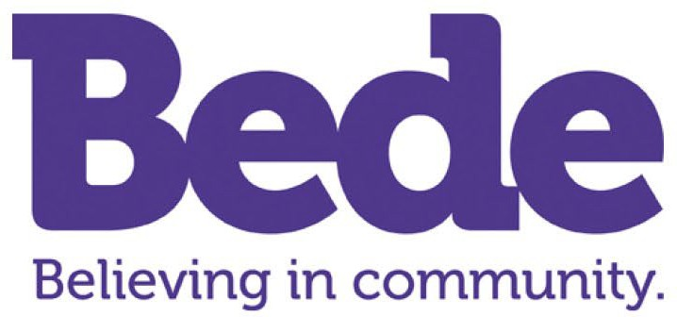

How to apply
If you are interested in applying, please email Gwen Green at gwengreen@bedehouse.org with answers to the following questions:

- How would you ensure that a person with learning disabilities’ choices are respected
and heard?
- What interests and skills do you have that could be useful in leading activities for people with LD?
- We love to use our local community as much as possible at Bede. How would you get the most out of your local area?

We are accepting applications on a rolling basis, so please apply early.

If you are successful in getting through this first stage, we will ask you to fill out an application form with your full employment history, and to provide ID documents to show you are eligible to work in the UK. We will also invite you to interview and spend a taster day at our Centre. You will get the chance to meet some of our clients, and this will be a chance to assess how you meet the requirement in the job description.

Bede works with children and adults at risk of harm, and we have Safer Recruitment policies and procedures in place to ensure that they are protected from abuse. These roles are subject to an enhanced DBS with a possible barred list check.

